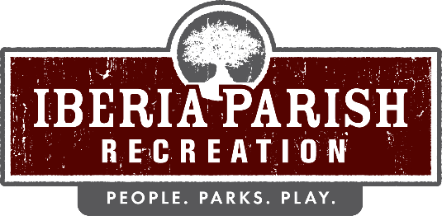

Agenda for the regular scheduled board meeting of the IBERIA PARISH RECREATION AND PLAYGROUND COMMISSION to be held on THURSDAY, OCTOBER 10, 2024 at 6:15 PM in the Meeting Room at the Administrative Office located at Willow Wood Park, 113 Willow Wood Drive, New Iberia, LA.

- Opening Prayer.

- Call to order.

- Roll call.

- Persons to address the board – 3 minutes/person

- Consider a motion to approve the minutes of the rescheduled regular board meeting held on September 19, 2024 meeting as published and take appropriate action.

- Consider a motion to authorize the Chairman to sign the Amendment to Lease, which is for the extension of the term of the current lease by and between Our Lady of Prompt Succor Roman Catholic Church, Diocese of Lafayette, Coteau, Louisiana and the Iberia Parish Recreation and Playground Board/Commission for the Francis Romero Memorial Park property located at 6310 Coteau Park Road, New Iberia, LA and take appropriate action.

- Receive a report on the 2024 Capital Improvements and take appropriate action.

- Discuss the proposed Iberia Parish Recreation and Playground Commission 2025 Capital Improvement Projects and take appropriate action.

- Announcements.
- Sales Tax Collection for the month of September 2024
- Recap of 2024 Sales Tax Collections
- New Line Dance Classes are now being offered at the Willow Wood
- Next meeting scheduled for November 14, 2024

- Correspondence.
  - Email from Captain Michael Hollier- dated September 30, 2024
  - Email from Pres Marshall- dated October 1, 2024

- Adjournment.

